

Y O U R T R U S T E D I T P A R T N E R

Simple Logic IT
Protect Your Company From Data Breaches
Catalog

w w w . s i m p l e l o g i c i t . c o m

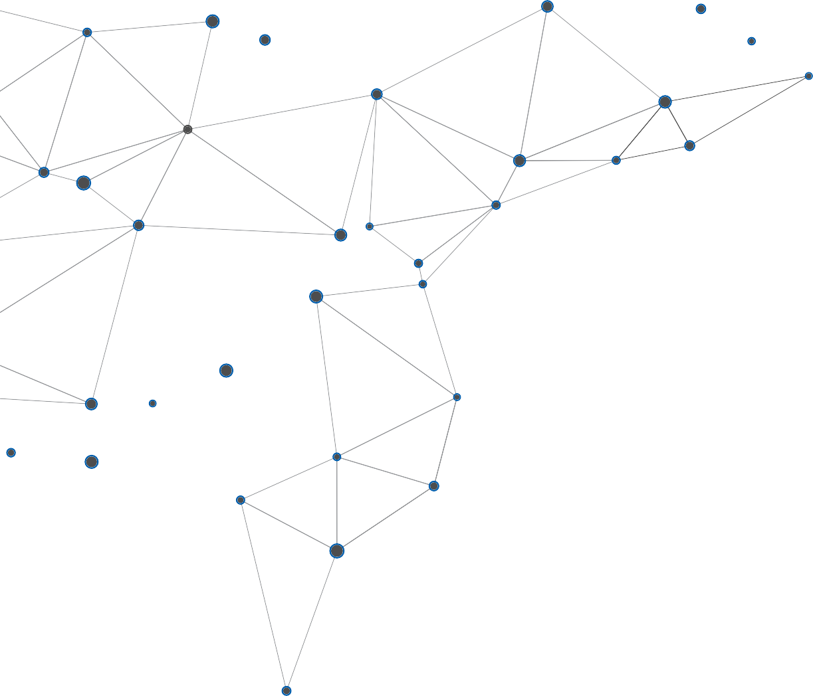
Simple logic at a Glance | 3
Vision and Mission | 4
Our Services | 5
- Technology Solutions | 5
- Software Solutions | 6
- Website Design & Development | 7
- Hardware & Networking | 8
- IT Infrastructure & LAN Design Solutions | 9
- Network Security & VPN Solutions | 10
- WIFI Solutions | 10
- The parking guidance system (PGIS) | 11
- People counting system | 11
- Security systems | 12
- EAS System | 12
- Digital Signage | 13
- ERP | 13
- AMC CONTRACTS | 14
We Supply | 14

3
Let’s turn your idea into an extraordinary digital product.

Simple logic at a Glance
Simple logic IT is one of the leading IT Company that offers complete IT solution aligned with current and future needs of the retail and corporate sector.

Who we are
Founded in the year 2007 in Qatar, Simple logic IT is entirely dedicated to the retail and corporate sectors. With our team of most skilled professionals and the large number of facilities using our products & services, simple Logic IT is specialized in the development, marketing, implementation and support of various software and hardware product such as ERP Solutions, Customized software solutions, Software Development, website Design & Development, Hardware & Networking, Sales and services, Security, Security System Services, Automatic Number Plate Identification & Data capturing Systems etc.
As the world continues to rely on the unmatched stability and consistency of the mainframe to support business-critical application, Simple Logic IT provides the software, experts and best practices to ensure those applications work well and deliver value. Simple Logic IT offers the most user-friendly and efficient solution to market, to the market, to maximize productivity and service quality at a minimal cost.



What Makes Us Unique
- Proven Success within short span of time
- Trusted, proven , industry leading products
- Excellent & dedicated after sale service
- Experienced & skilled professionals
- Agile and innovative with renewed energy
- Aligned with latest technologies
- Strong backend team in India, Qatar and UAE

Values
Superior Services and support Easy to buy Easy to use.

Vision
Constant focus on improvement Be Simple, not the complex quality products & Services .

Mission
Consistently meet customers’ expectations value driven expertise Utmost perfection of products and after sale service.

5


Our Services
Technology Solutions
Simple Logic IT software solutions are developed using the latest technologies. We provide unparalleled platforms for our customers to choose from, in accordance with their business needs and priorities.

Our products in Demand
- Retail store Management
- Trading Management
- Restaurant Management
- ERP& CRM solutions
- HR& Payroll Software
- Asset Tracking Software
- Document Management Software
- Time Attendance Software
- Finance Management Software
- Administration Management
- SPA & Beauty clinic
- ERP for Bulk Readymade Units.
- Digital Signage Solution
- Loyalty programs solutions

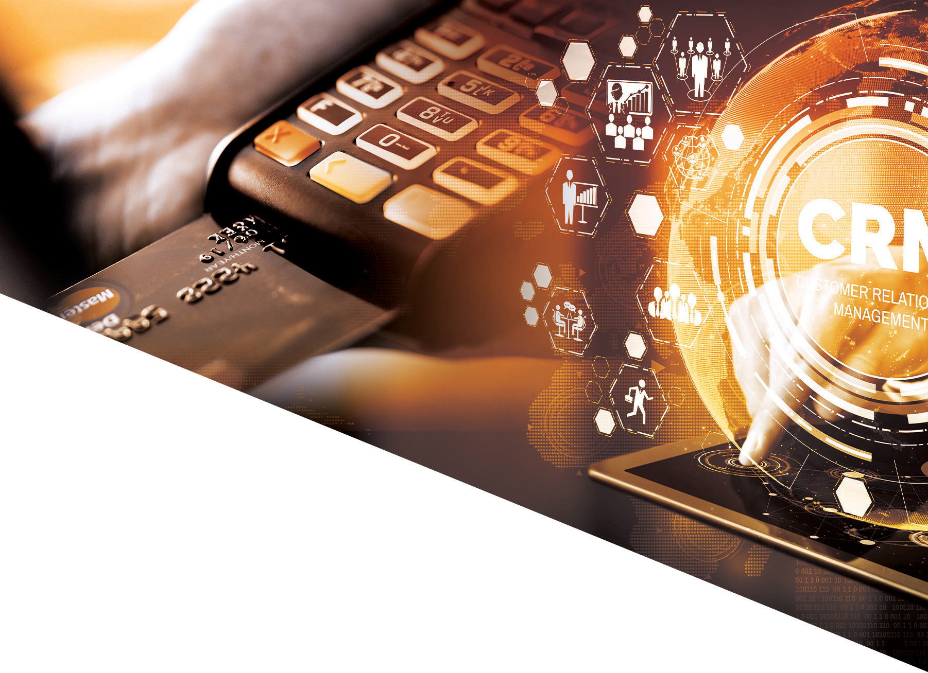Software Solutions
Simple Logic IT delivers software projects to customers from start-ups & SMB multinational corporates. Having a balanced blend of technology skills and domain knowledge of seasoned IT professionals, powered by passion for IT, simple Logic software solutions guarantee you enhanced productivity and performances. Whether it is retail or health care or administrative division, Simple Logic has a software solution to enhance its productivity.

Highlights
  - Custom Applications Management
  - Customized ERP and CRM development
  - Application Re-engineering
  - IT Consultancy
  - Device Programming (PDA/ PDT/Price checker)
  - Supports &Maintenance
  - Mobile Application Development
  - Web application development & ecommerce sites

7

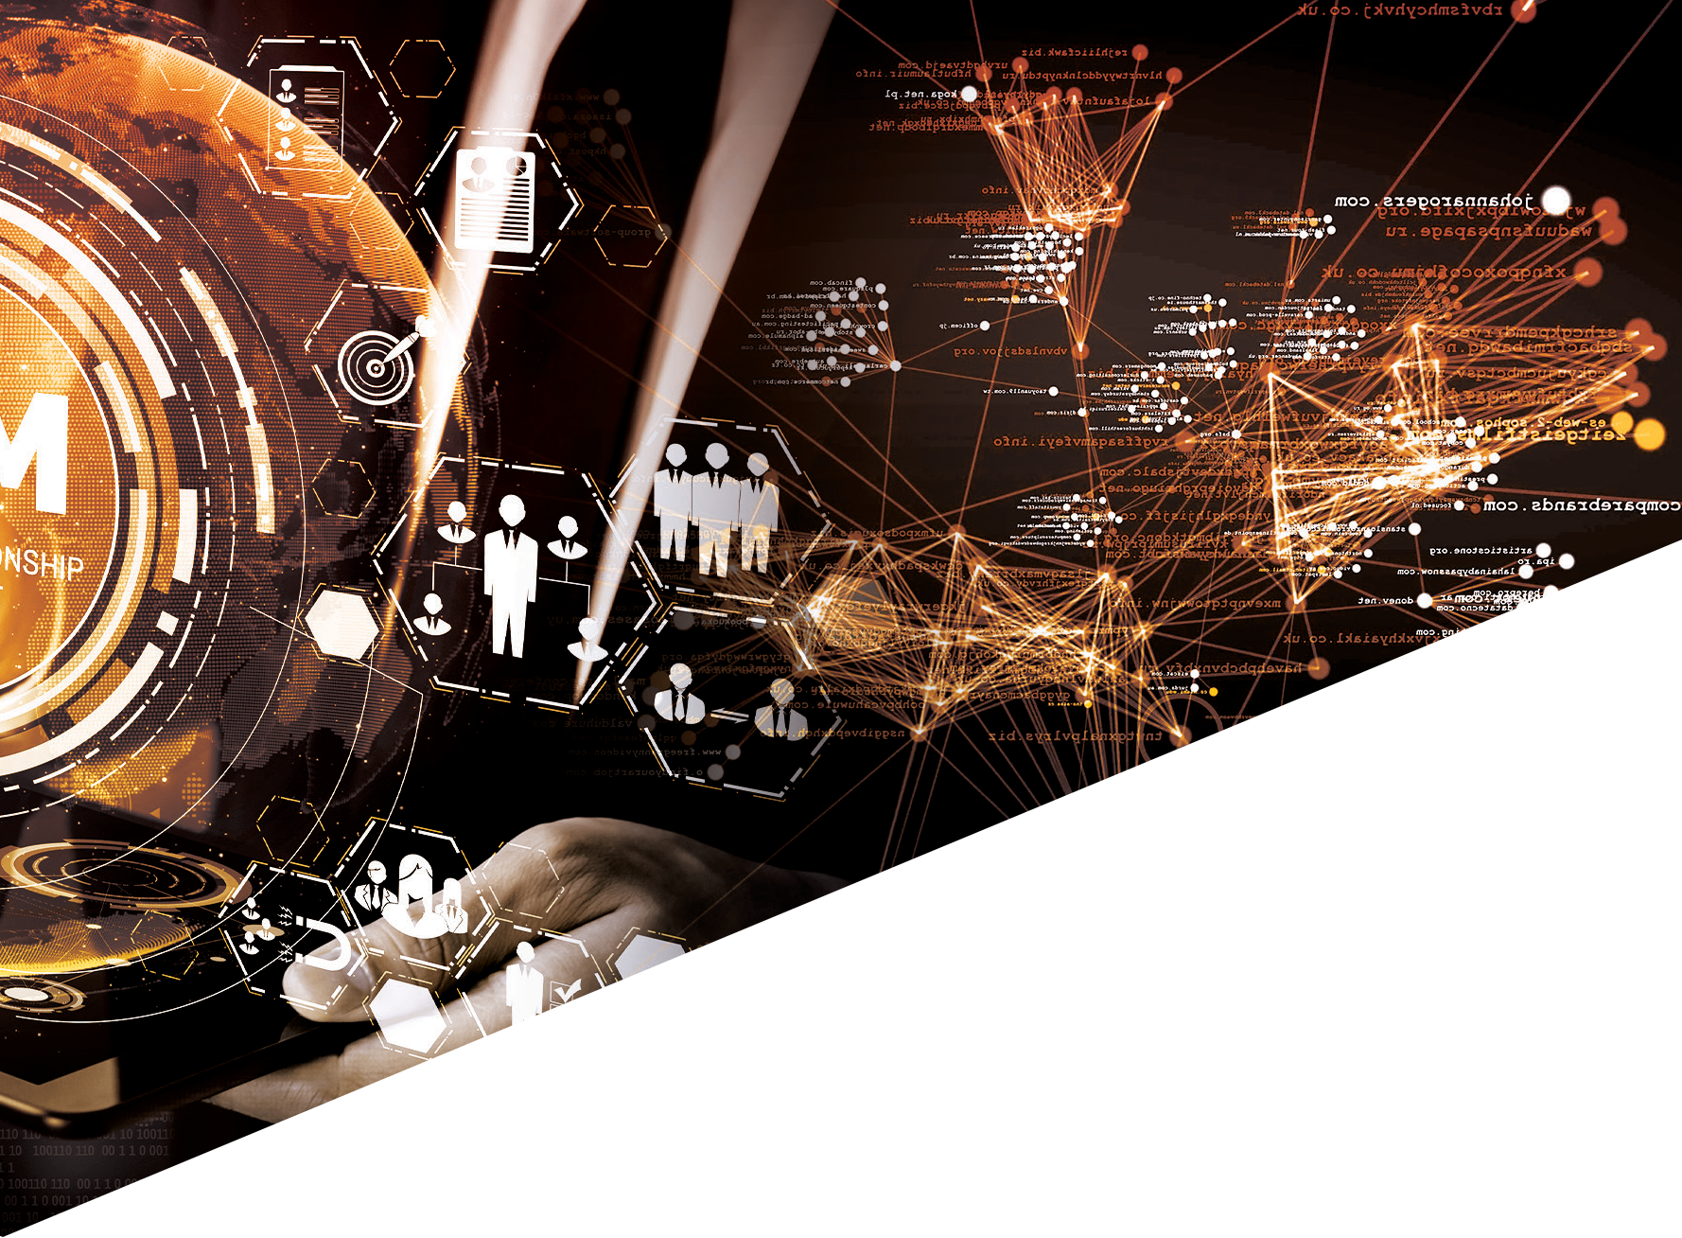

Simple Logic IT is turnkey design shop offering
the full complement of services including
  - Custom website design
  - Web graphics
  - Logo development
  - Flash development
  - Website usability, User interface (UX)
  - Brand development
  - Valid XHTML coding & CSS
  - Hosting & Maintenance
  - Website Promotions

Website Design & Development
Simple Logic IT gained reputation as a website design company with a staff of professional website designers and e-commerce website developers. Our goal is simple; provide our clients with the best possible web design services at a reasonable price. And, since its inception in 2007, that’s what we’ve been doing. We’ve built our business on integrity and trust, all of which has earned us a lot of happy referrals and repeat business.

Succesful projects
need smart tech-

nology

Hardware & Networking

At Simple Logic IT, we understand that a reliable and secure technology infrastructure is essential for the smooth functioning of any organization. That’s why we offer comprehensive hardware and networking solutions to help you build and maintain a robust network.
Our team of certified professionals will work with you to design and implement a customized solution that meets your specific requirements. We offer a wide range of hardware and networking services, including server installation and maintenance, network security, cloud computing, and much more. Contact us today to learn more about our hardware and networking solutions.

The Networking solutions that we offer cloud
broadly classify as
  - IT Infrastructure & LAN Design
  - Network Security & VPN Solutions
  - Security Systems & Access Control
  - Supply installation and maintenance of PCs and servers
  - EAS System
  - Queue Management System
  - Parking Management & Guidance System
  - LED Screens & Digital Signage
  - People Counting Systems
  - UPS Solutions.
  - Hardware Sales & AMC Support
  - Networking Solution & AMC Support

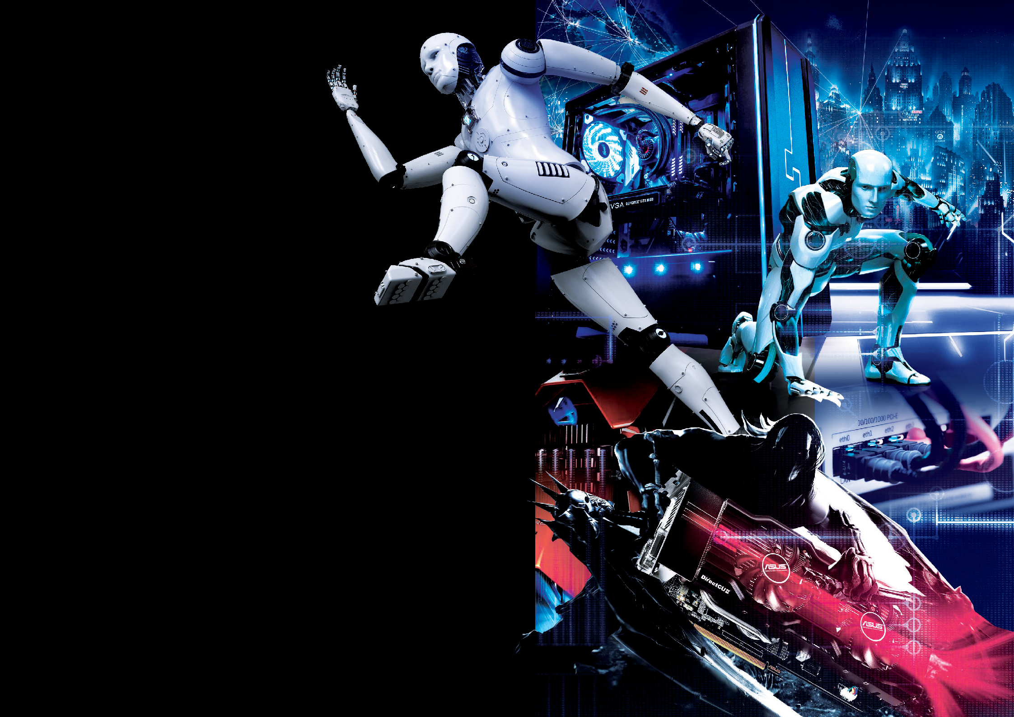9

IT Infrastructure & LAN Design Solutions

We provide end-to-end solutions that cover every aspect of IT infrastructure and LAN design, from planning and design to implementation, testing, and ongoing support.
Our solutions are based on the latest technologies and best practices, ensuring that you get the most out of your IT infrastructure and LAN design investments. We also provide ongoing support and maintenance to ensure that your IT infrastructure and LAN design remain in top condition, with minimum downtime and maximum uptime. Whether you need to upgrade your existing IT infrastructure and LAN design, implement a new solution, or optimize your current environment, we have the expertise and experience to deliver the results you need.

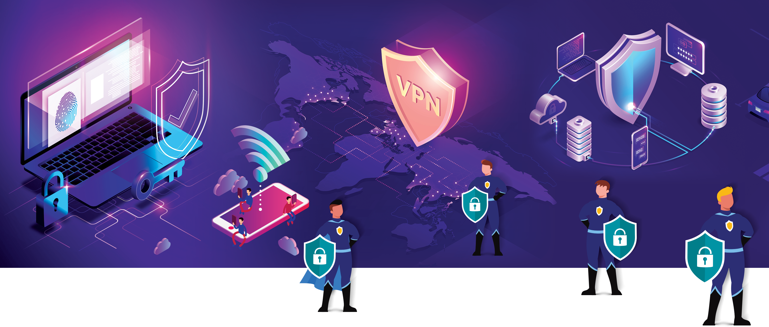
Network Security & VPN Solutions

At Simple Logic IT, we understand the critical importance of network security and VPN solutions in today’s digital landscape.
We offer a comprehensive range of network security and VPN solutions to help you protect your data and network from cyber threats and ensure secure remote access. Our network security solutions include firewall protection, intrusion detection and prevention, content filtering, and more, designed to keep your network safe from external and internal threats.

WIFI Solutions
We believe that access to reliable and fast wireless connectivity is a fundamental need in today’s world. Our solutions are designed to deliver high-speed, secure, and reliable wireless connectivity to your employees, guests, and customers. We offer a wide range of Wi-Fi services, including Wi-Fi network design and installation, network security, and ongoing support and maintenance.

11

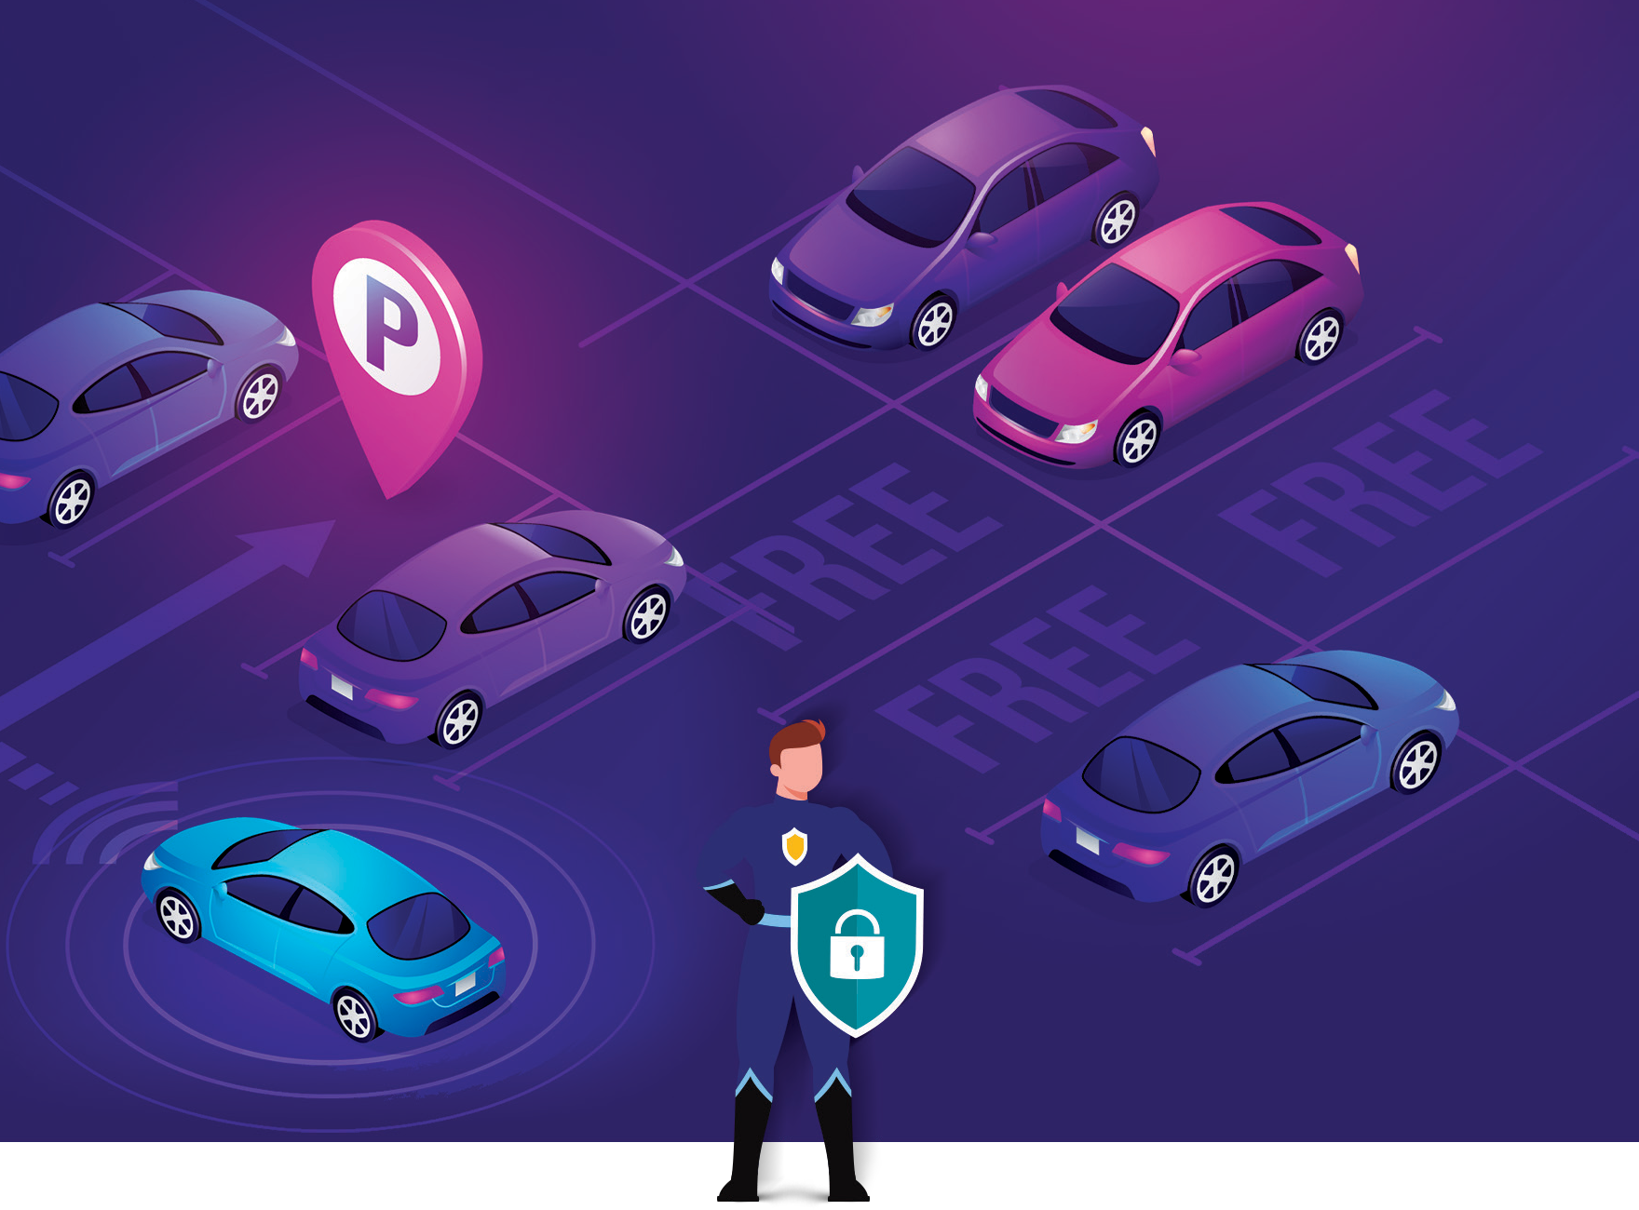
People counting system
We believe that accurate data is key to optimizing business operations. That’s why we offer innovative people counting systems to help you track and analyze traffic flow in your facilities. Our people counting solutions use advanced sensors and algorithms to accurately count and report the number of people entering and exiting your premises. Our people counting systems are easy to install, user-friendly, and integrate seamlessly with other technologies.

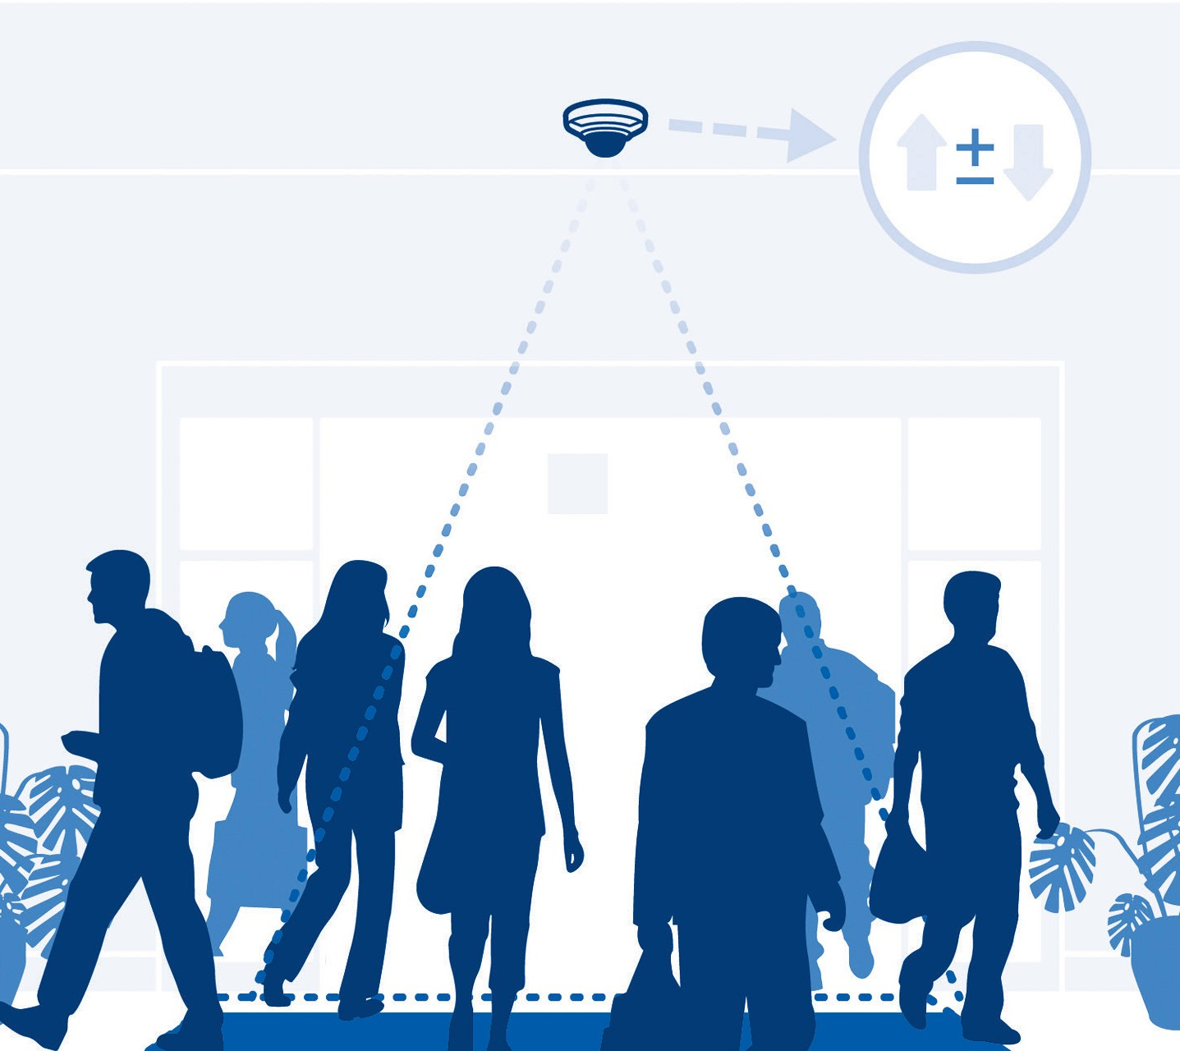
The parking guidance system (PGIS)
We offer innovative parking management solutions to help you optimize and streamline your parking operations. Our parking management solutions include parking reservation systems, license plate recognition technology, parking access and revenue control systems, and more. Our goal is to provide you with a comprehensive and user-friendly solution that increases efficiency, reduces costs, and enhances the overall parking experience for your customers and employees.

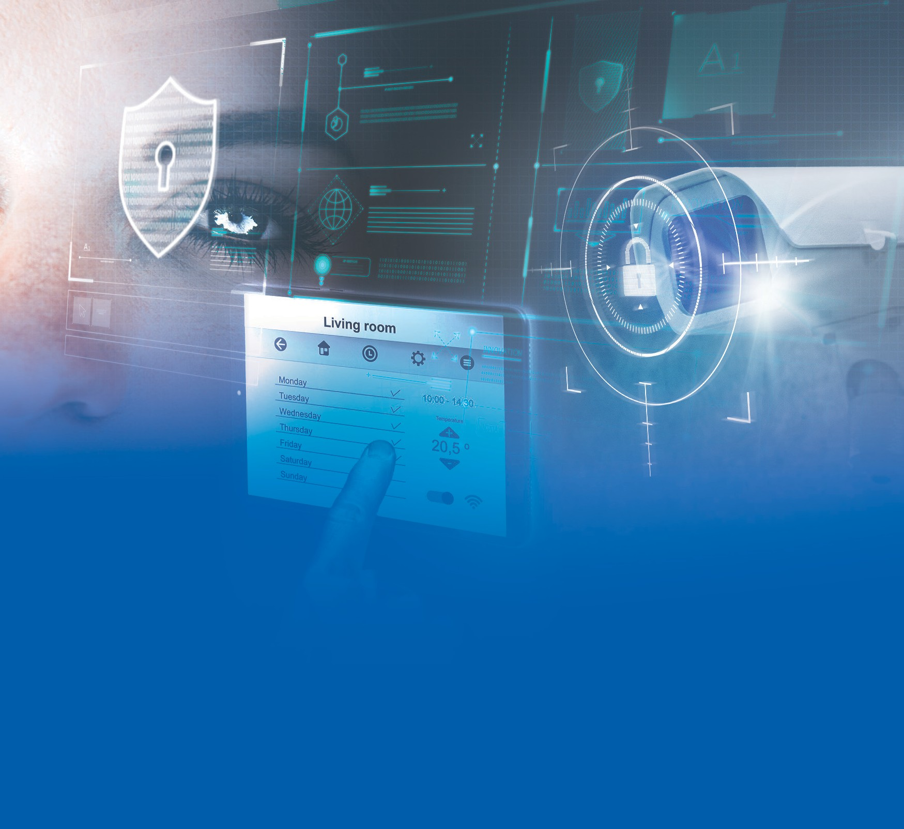Security systems
We understand the critical importance of securing your assets, employees, and facilities. We offering a range of security solutions designed to protect your organization from threats and minimize risk. Our team of security experts will work with you to design and implement a customized security system tailored to your specific needs. Our security solutions include video surveillance, access control, intrusion detection, and more. We use the latest technologies and industry standards to provide you with a robust and scalable security system that is easy to use and manage.
  - CCTV Security system.
  - EAS system.
  - Door Access control system.
  - Biometric control system.

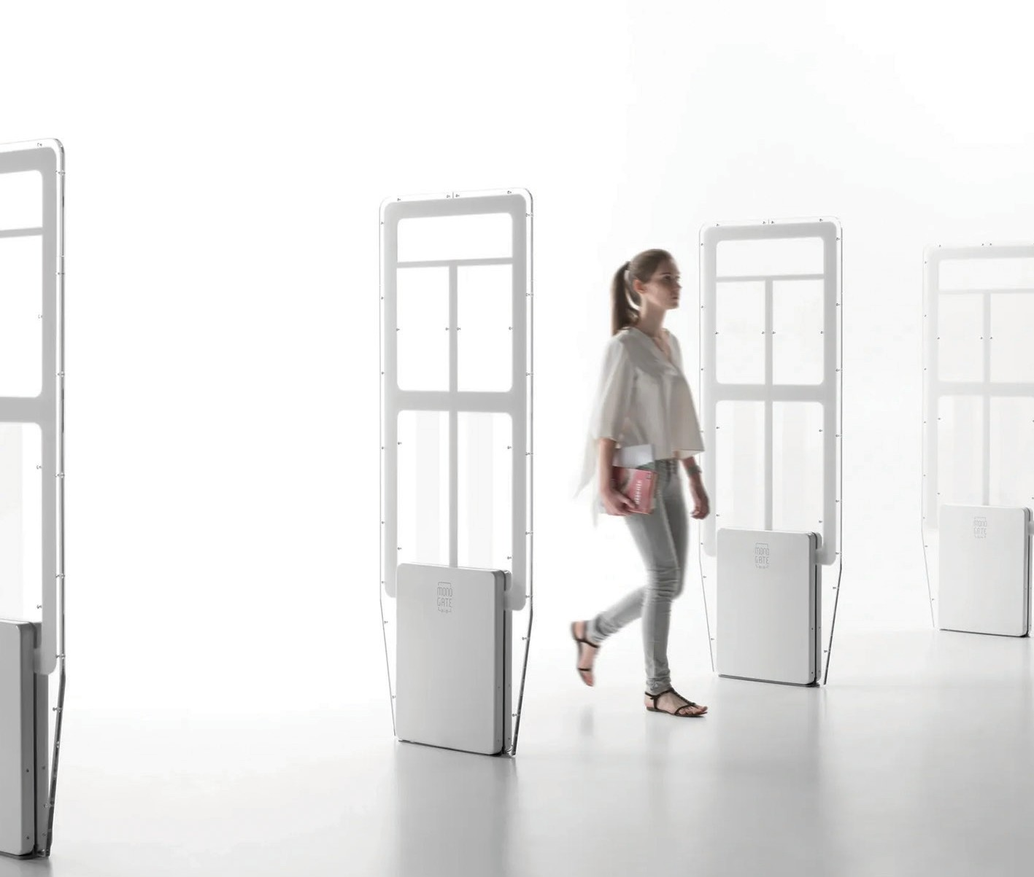
EAS System
We understand the challenges of retail loss prevention. Electronic Article Surveillance (EAS) systems to help retailers protect their products and reduce loss. Our EAS systems use advanced technology to detect and deter theft at the point of sale, without affecting the shopping experience of customers. Our EAS solutions include RFID and AM technology, hard tags, and detachers, as well as software to manage and track inventory.

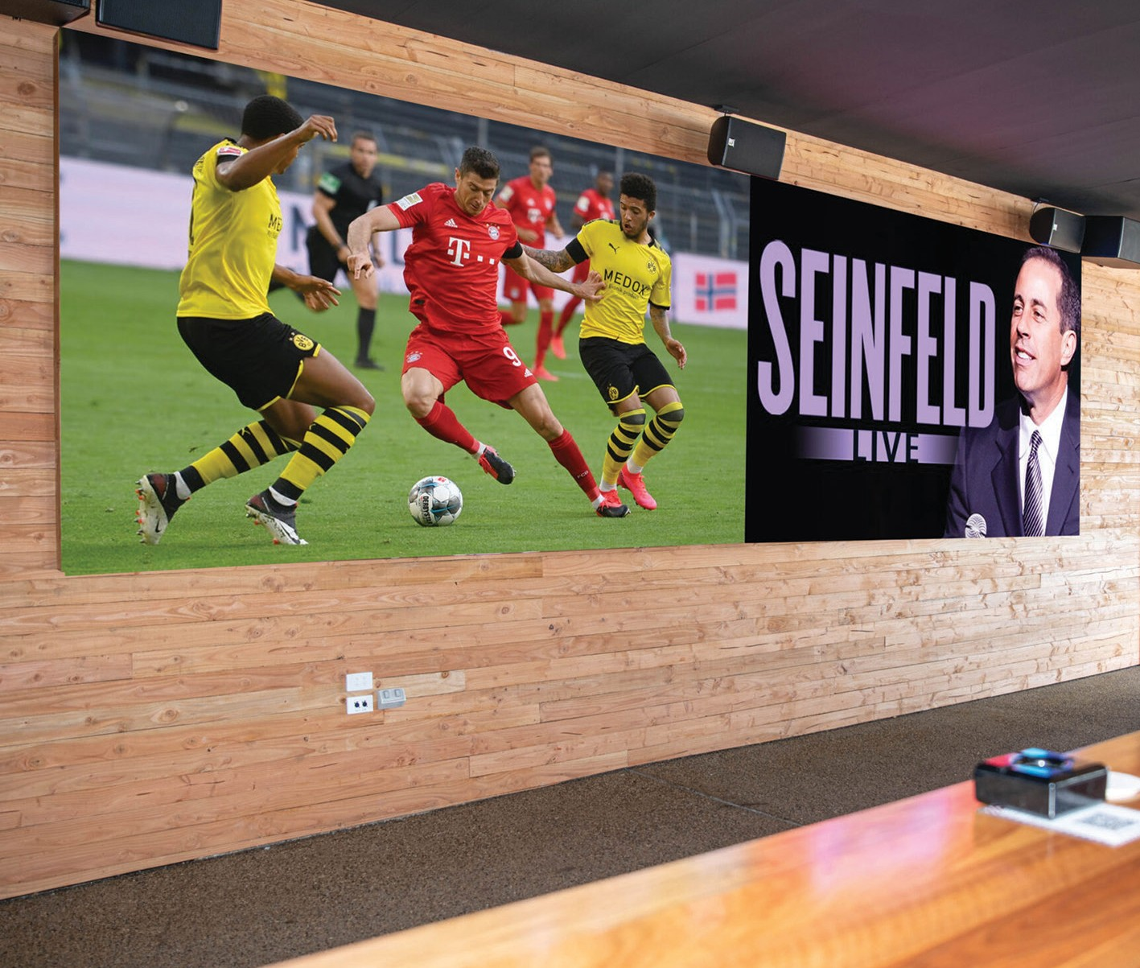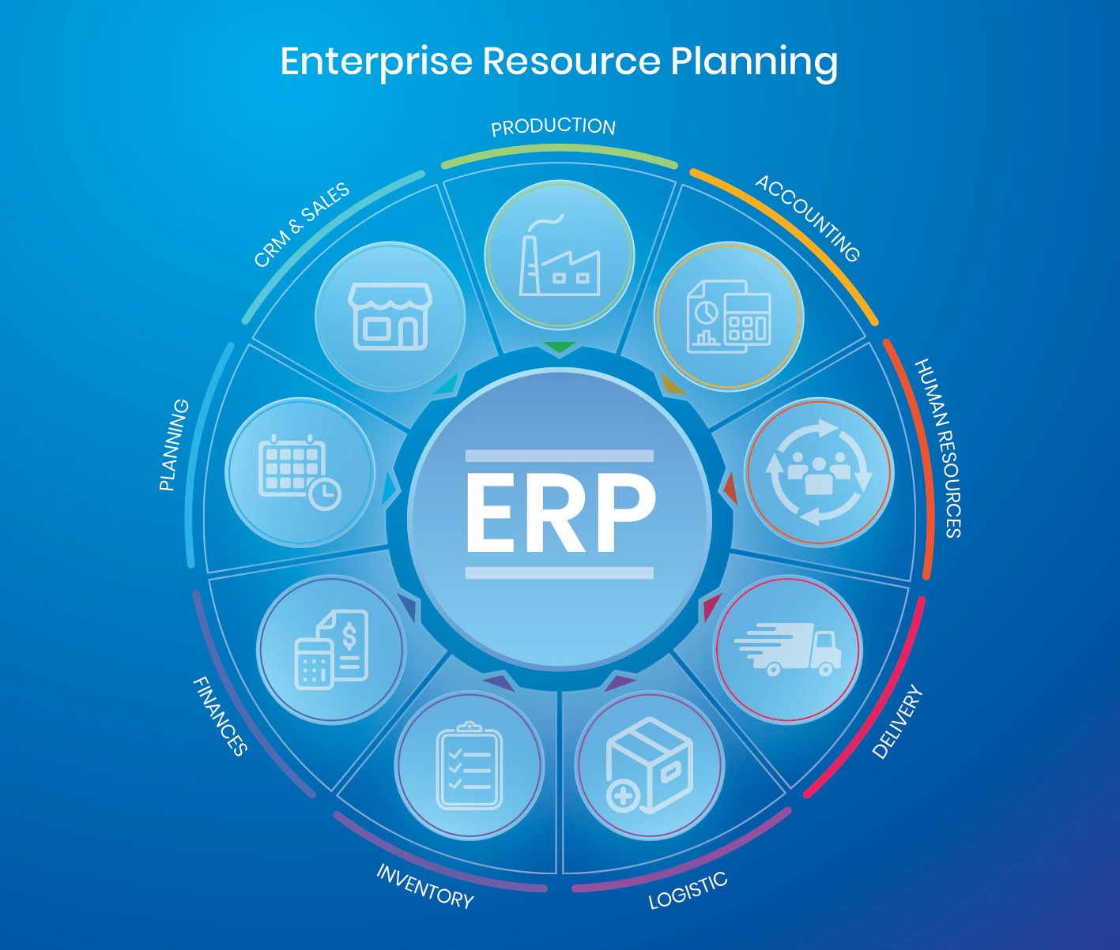

13

Digital Signage
Our digital signage solutions allow you to display dynamic and interactive content such as images, videos, and real-time information on screens in your facilities. This can be used to promote products, share important messages, and improve customer experience. Our digital signage solutions are easy to install, use, and manage, and can be tailored to your specific needs.
ERP
Enterprise Resource Planning (ERP) solutions to help organizations manage their business operations effectively. Our ERP solutions provide a comprehensive view of all aspects of your business, including finance, sales, procurement, and human resources. With our ERP solutions, you can automate processes, make informed decisions based on real-time data, and improve operational efficiency. Our team of experts will work with you to design a customized ERP solution that meets your specific needs and helps you achieve your business goals.

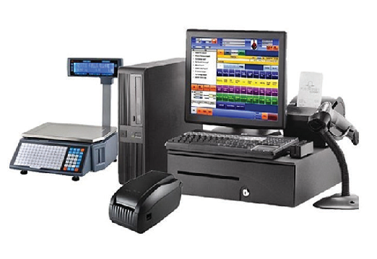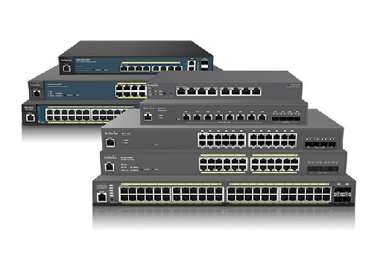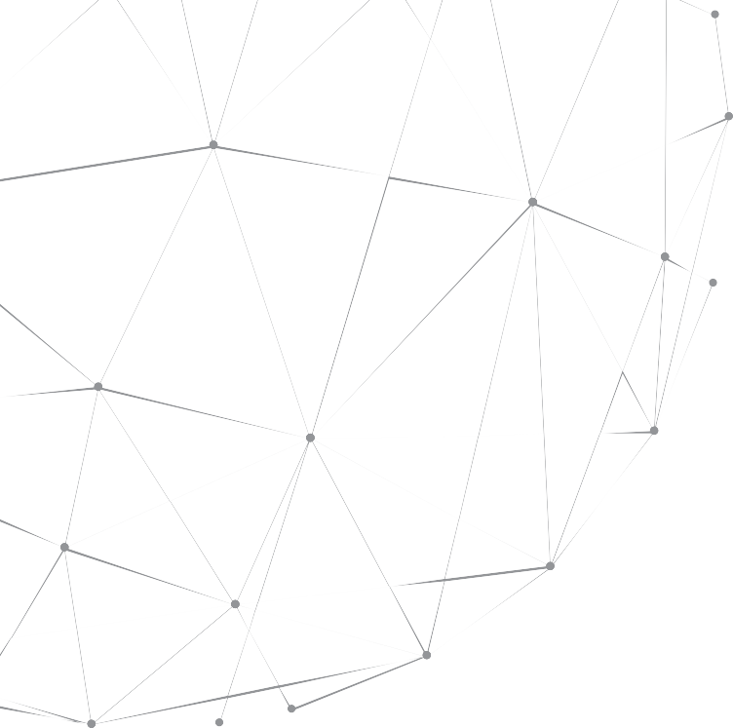
Hard Tags
Network Switches
System

AMC CONTRACTS
We recognize the significance of maintaining your technology systems in optimal condition. That’s why we offer Annual Maintenance Contracts (AMC) to ensure that your IT infrastructure is well-cared for and protected against potential issues. Our AMC services include regular monitoring, software updates, hardware maintenance, and troubleshooting. Our team of experts will work with you to create a tailored AMC plan that meets your specific needs and ensures the best performance of your technology systems.

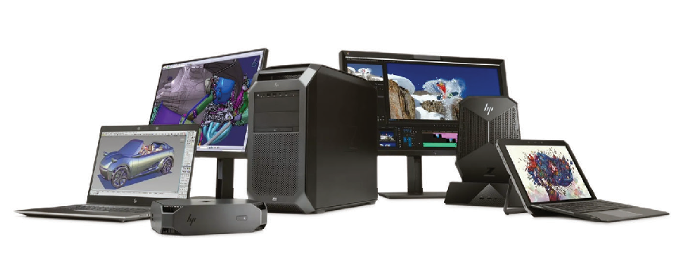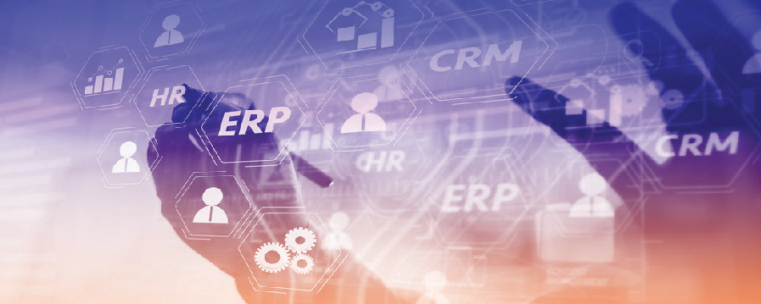

Desktop & Systems

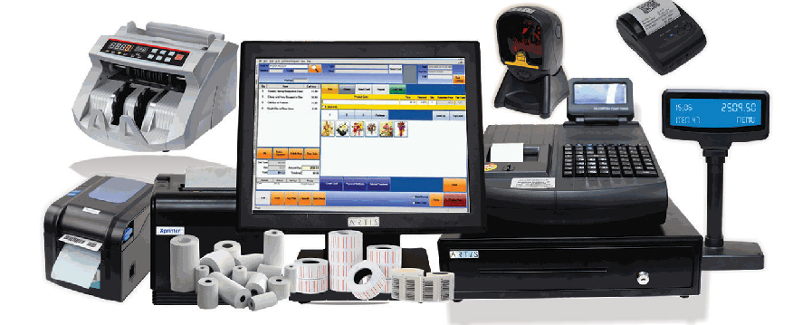
Retail System
ERP Software Solution
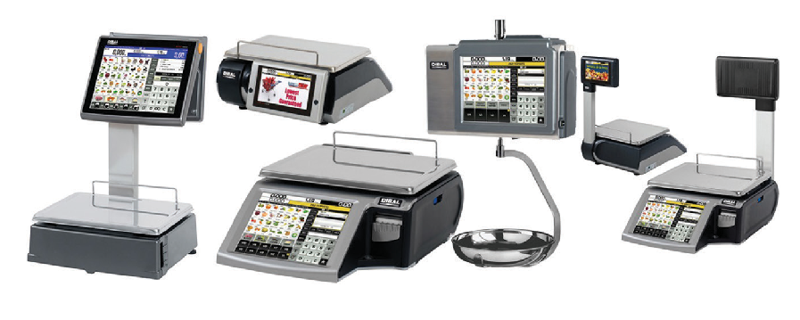
Weighing Scales

15
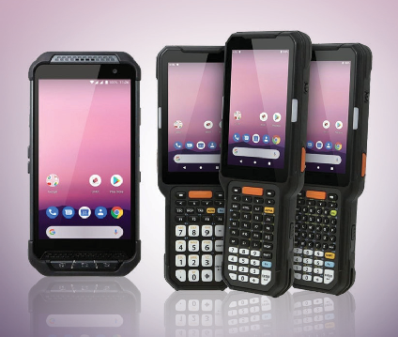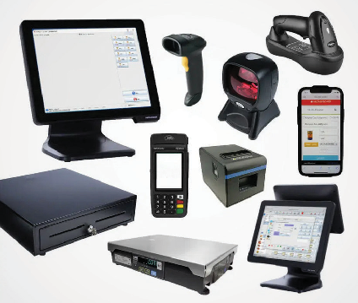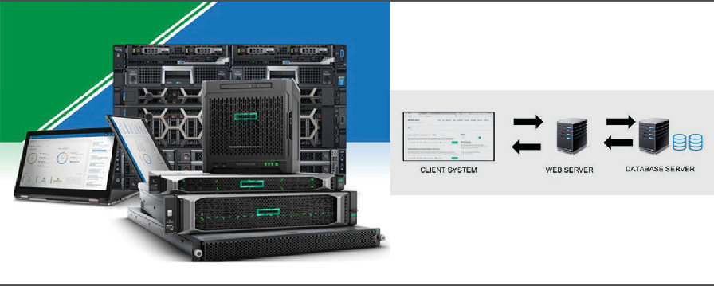
PDA Retail System (POS) Servers


Y O U R T R U S T E D I T P A R T N E R

w w w . s i m p l e l o g i c i t . c o m
First Floor, Safari Mall, Muweilah, Sharjah - UAE P.O.Box: 904
Mobile : +971 6 5066 966, +971 56 511 4805
E-mail: sales@simplelogicit.com www.simplelogicit.com

